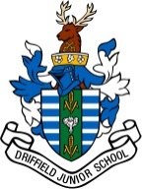

Dear Parents/Carers

CYCLE 4 LIFE CHALLENGE – THE WOLDS 100

Next Thursday, 20th June, three of our staff, Mrs Mudd, Miss Wilson and Mrs Hakner, are joining staff from other schools on a Cycle 4 Life 100km Staff Challenge Ride, visiting schools along the way.

The event will begin from Driffield Junior School and we are delighted to announce that the staff will be joined for the day by UCI Road and Track World and Olympic para champions, Steve Bate and tandem pilot Adam Duggleby, a truly inspirational pair.

You can find out more about Steve and Adam by following these links:
https://www.britishcycling.org.uk/gbcyclingteam/new/bio/Steve_Bate
https://www.britishcycling.org.uk/gbcyclingteam/new/bio/Adam_Duggleby

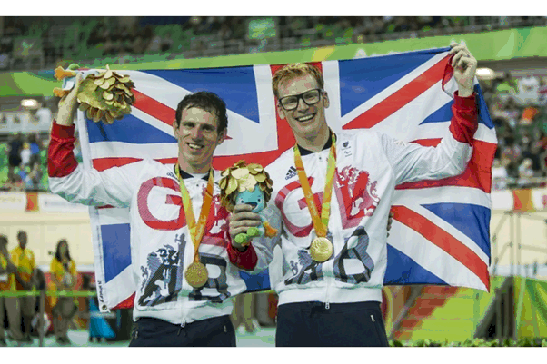
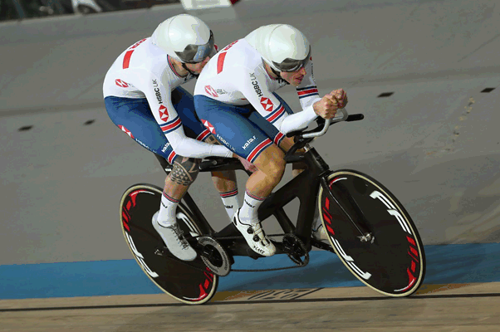

Similar to the Tour de France and the Tour de Yorkshire, we are also very lucky to have the Yorkshire 2019 UCI road World Championship organisers with their specially decorated car to hand out goodies.

We would like to give them an amazing DJS send off and hope that children can be here at 8:30 am, when the gates open. Children will be creating some flags and banners early next week and we ask that as many as possible be here to cheer them on their way. Parents/carers are very welcome to join in the fun too.

The riders will leave at 8:45am prompt
from the school playground onto Manorfield Avenue

We wish Mrs Mudd, Miss Wilson and Mrs Hakner the best of luck for their challenge.

